

Getting Started Guide

|  |
| --- |
| *KPA Flex can be used from your computer's web browser (Chrome is*  *recommended for best performance) or from the iPhone/Android app.* |
| *This guide explains both methods.* |

|  |
| --- |
| *For additional information,* |
| *check out the help articles using the link below:* |
| **KPA** [**Fle**](https://support.kpaehs.com/hc/en-us)**x Help A**[**rti**](https://support.kpaehs.com/hc/en-us)**cle**[**s**](https://support.kpaehs.com/hc/en-us) |

***Using KPA Flex from your computer***

|  |
| --- |
| 1) Login to the website |
| *The welcome email will contain your login credentials as well as a link to your company's website. Enter your login credentials on your company's website login screen.* |

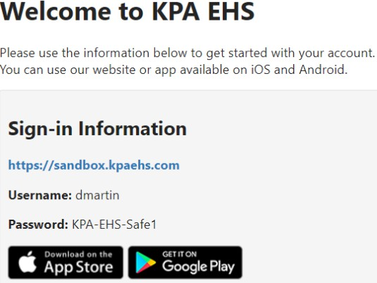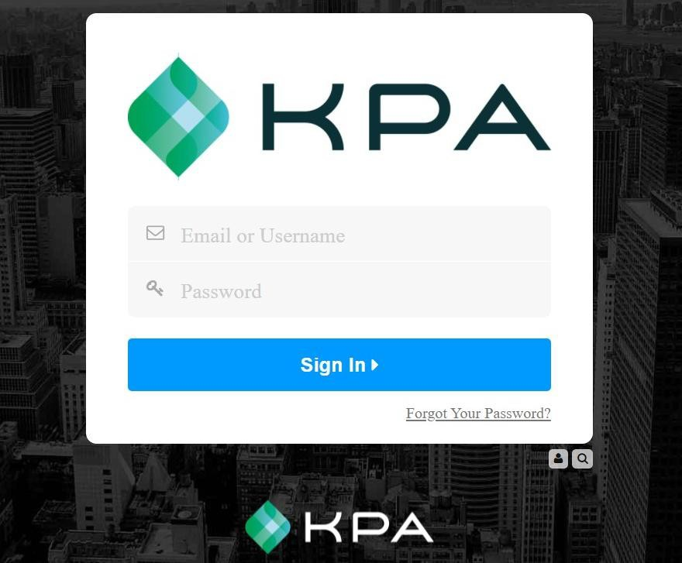

|  |
| --- |
| 2) Choose a password |
| *Choose a new password, enter it twice, and then press "Continue". Passwords must be at least 12 characters and contain an uppercase, lowercase, and number.* |

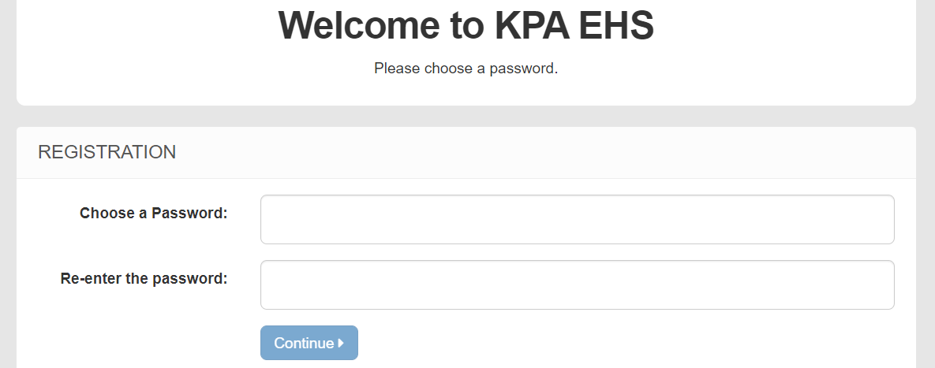

|  |
| --- |
| 3) Dashboard |
| *This is your homepage. If you have assigned open tasks to complete, you will see them listed here.*  *\*Note: This will be based on access level \** |

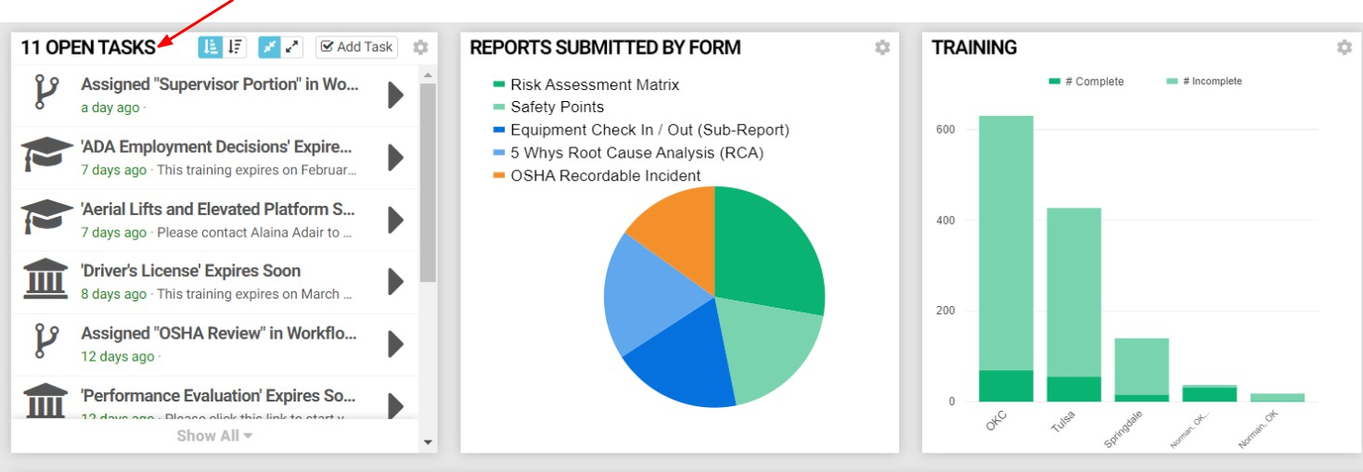

|  |
| --- |
| 4) Choose a form |
| *You'll also see a list of forms you can fill out. Click the Fill button to start filling it out.* |

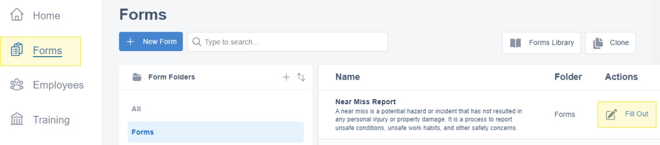

|  |
| --- |
| 5) Fill Out the Form |
| *Now you can fill out the form. If you are prompted for access to your location, be sure to allow access to your location. Press "Submit" when finished.* |

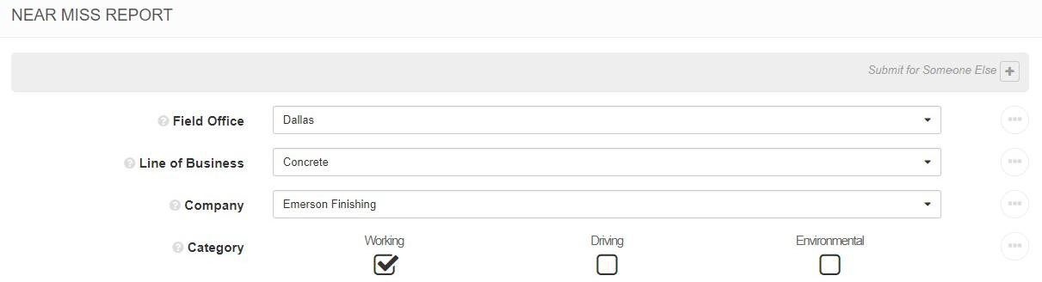

|  |
| --- |
| 6) Success |
| *That’s it! You have successfully submitted a form via the website.* |

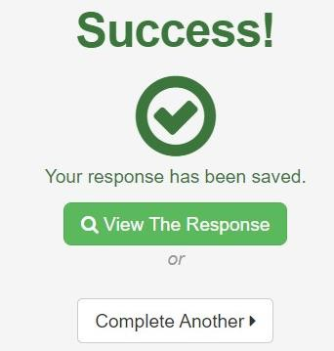

|  |
| --- |
| 7) Menu Options |
| *The menu on the left allows you to navigate the website. You can view the home page or you can press “Forms” to submit a form. *Note: options shown will be based on access level\** |

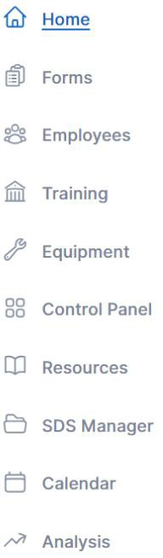

|  |
| --- |
| ***How To Use the KPA Flex App*** |
| *The KPA Flex App is available for iPhone, iPad, and Android devices.*  *The app allows you to ﬁll out reports without an internet connection, receive notiﬁcation, and more.* |

|  |
| --- |
| 1) Install the App from the App Store |
| *iPhone and iPad users can search “KPA Flex” in the Apple App Store. Android users can search “KPA Flex” in the Google Play Store. *Note: The KPA Flex app is free.\** |

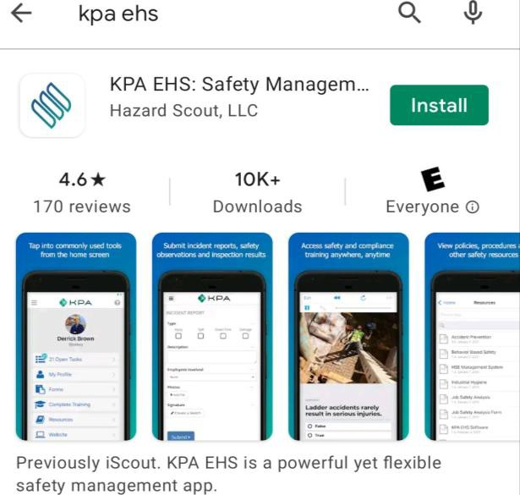

|  |
| --- |
| 2) Open the App |
| *Once you download the app from the App Store, you should see a KPA Flex icon on your device. Click on the app icon.* |

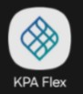

|  |
| --- |
| 3) Allow Access |
| *The app will ask to allow access to your photos and media. Make sure you press ALLOW when you are prompted.* |

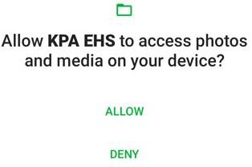

|  |
| --- |
| 4) Sign In |
| *Now sign-in using your same username and password that you would use on the website. Your login info was provided by your company. Be sure to use your new password if you changed it.* |

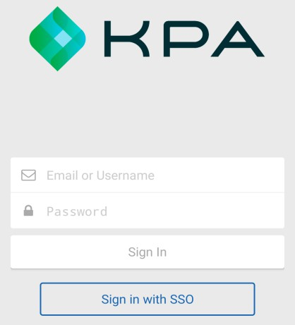

|  |
| --- |
| 5) Domain Name |
| *If the app asks for your Domain, this will be the portion between https:// and .kpaehs.com from your*  *website:* |

In this example, sandbox would be the Domain

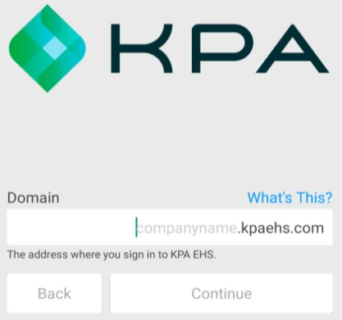

|  |
| --- |
| 6) Enable Notifications |
| *Now you need to conﬁrm that the system can send alerts to this device. Press “Yes” then continue.* |

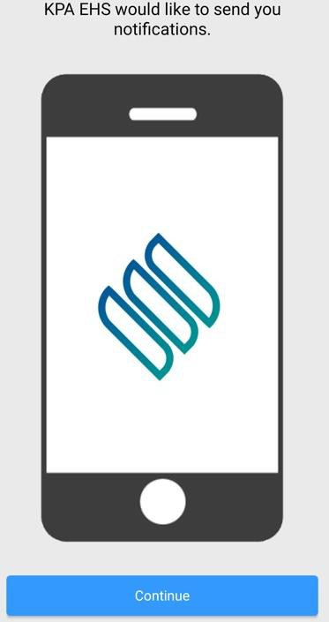

|  |
| --- |
| 7) Home Screen |
| *Congratulations, you’re in! You should see your name along with a few diﬀerent links for your open tasks, forms, trainings, resources, etc.* |

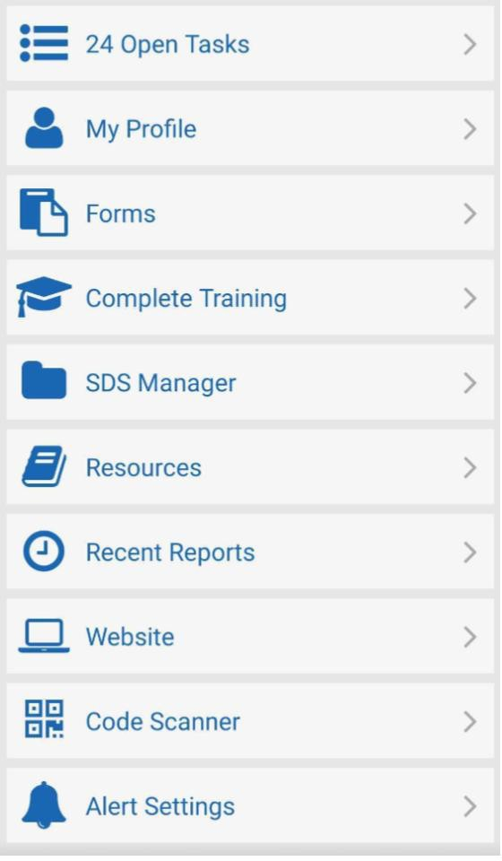

|  |
| --- |
| 8) Open Tasks |
| *The open tasks will show your current tasks to complete. These are your assigned trainings, forms, and inspections to complete. Click into each task to complete each one.* |

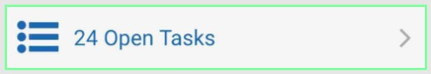 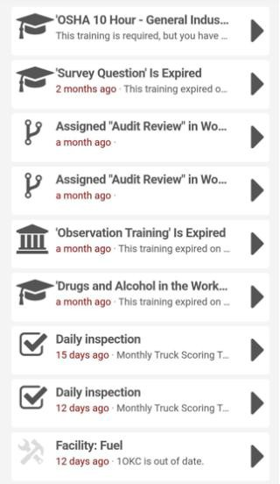

|  |
| --- |
| 9) My Profile |
| *My profile will show your unique QR code, profile data, and your completed training records.* |

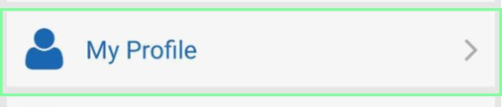

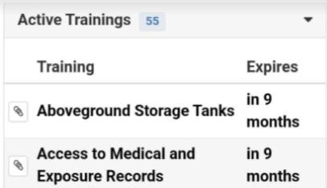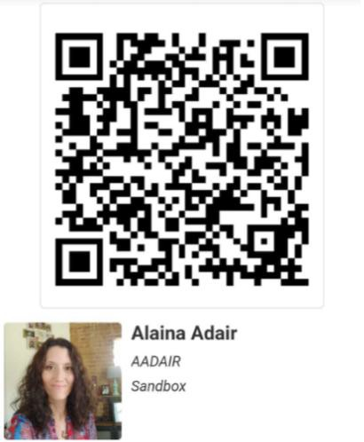

|  |
| --- |
| 10) Forms |
| *To submit a form, press the “Forms” button then choose the folder, then the form.* |

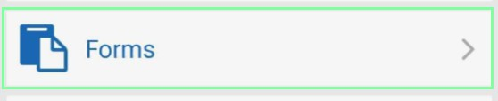 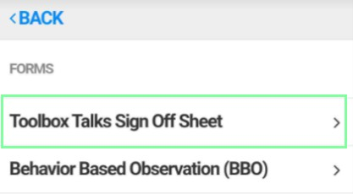 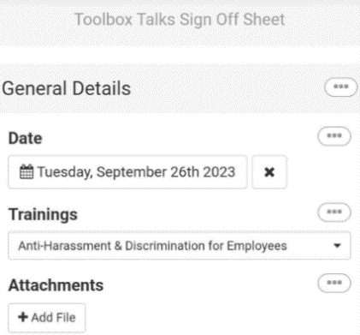

|  |
| --- |
| 11) Complete Training |
| *Complete Training are trainings NOT required trainings but available to take. To complete your required trainings, go through your Open Tasks.* |

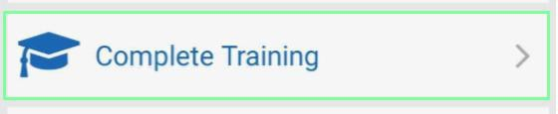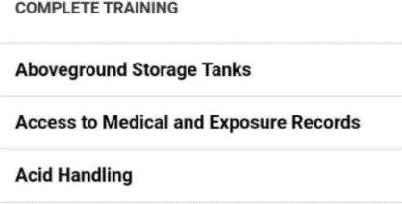

|  |
| --- |
| 12) SDS Manager |
| *If your company subscribes to SDS Manager, you will see the option to pull SDS from the app.* |

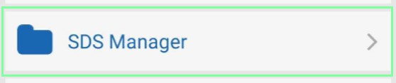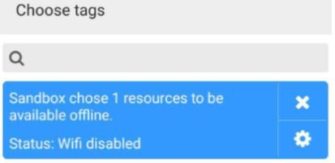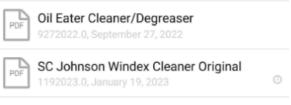



|  |
| --- |
| 13) Resources |
| *You can view your company’s resources (PDFs, etc) by pressing the “Resources” button.* |

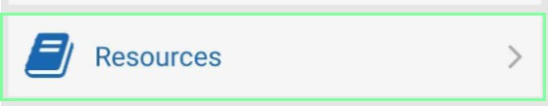 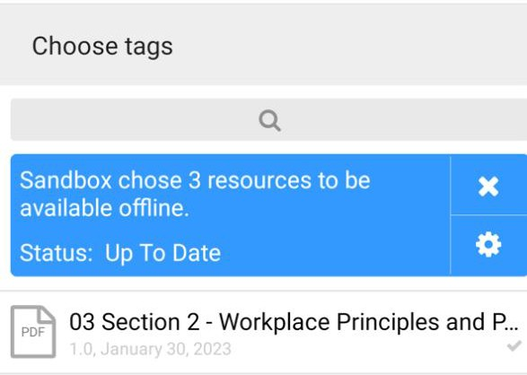

|  |
| --- |
| 14) Recent Reports |
| *Once you submit a form, it will create a section on the app called "Recent Reports". If it was submitted with connectivity, it will be uploaded immediately. If you didn't have connectivity, then the form response will stay in “Recent Reports” until a connection is established. You can view the “Recent Reports” screen to see if any form responses are still on your device.* |

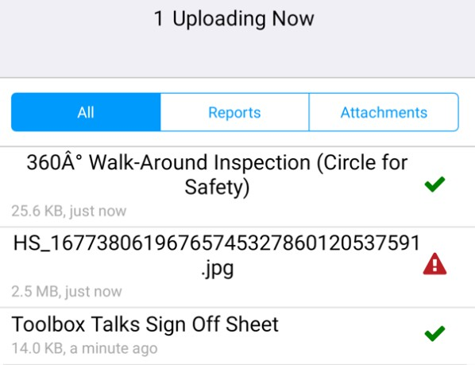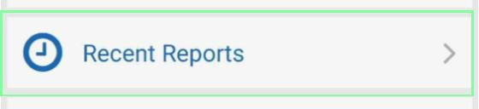

|  |
| --- |
| 15) Website |
| *The website button will allow you to get the full functionality of the website within an app view. Click*  *on the menu button to see the menu options.* |

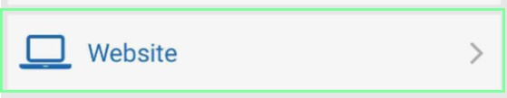 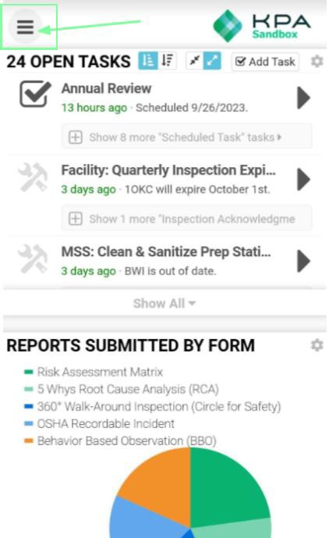 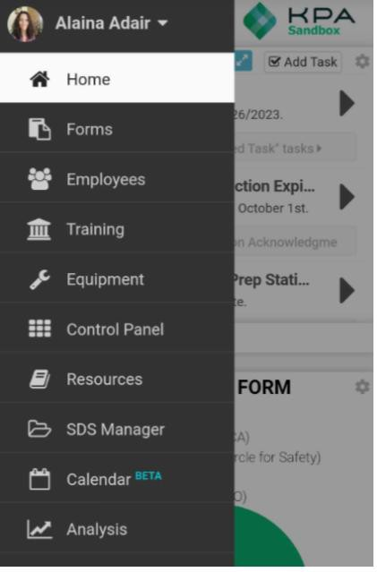

|  |
| --- |
| 16) Code Scanner |
| *Each employee and equipment added to KPA will have a unique QR code generated for that profile. The Code Scanner allows you to scan employee or equipment profiles.* |

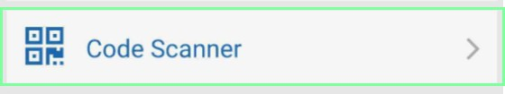

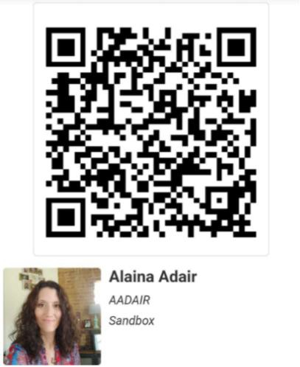

|  |
| --- |
| 17) Alerts |
| *Press the “Alert Settings” button to make sure alerts are enabled for your device. Your employee proﬁle on the website will let you send yourself a test alert to make sure it is setup properly.* |

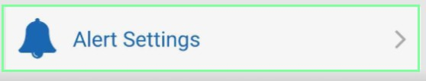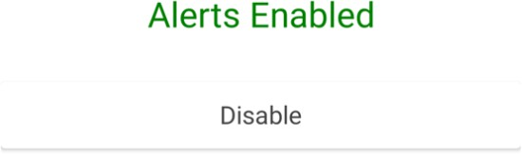

|  |
| --- |
| 18) iOS Alert Style |
| *By default, iPhone will show alerts at the top of the screen. If you wish to show them in the center of the screen, go to Settings App > Notiﬁcations > KPA Flex > Alert Style, & choose “Alerts”.* |

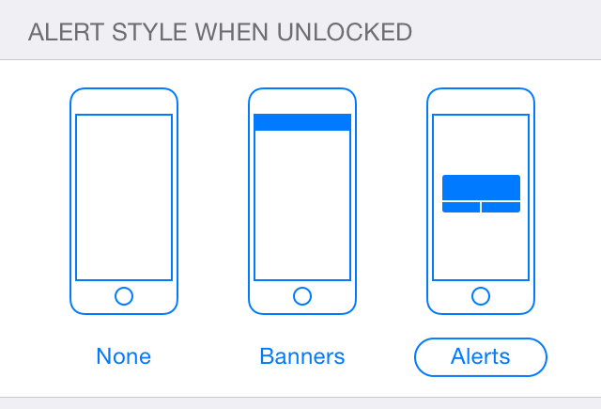

|  |
| --- |
| ***For additional information, checkout our Video Guides:*** |
| [**KP**](https://www.youtube.com/%40kpaflex/videos)**A Fle**[**x**](https://www.youtube.com/%40kpaflex/videos) **Help** [**Vi**](https://www.youtube.com/%40kpaflex/videos)**de**[**o**](https://www.youtube.com/%40kpaflex/videos)**s** |