

Getting Started Guide

**Training Only**

|  |
| --- |
| *KPA Flex can be used from your computer's web browser (Chrome is*  *recommended for best performance) or from the iPhone/Android app.* |
| *This guide explains both methods.* |

|  |
| --- |
| *For additional information,* |
| *check out the help articles using the link below:* |
| **KPA** [**Fle**](https://support.kpaehs.com/hc/en-us)**x Help A**[**rti**](https://support.kpaehs.com/hc/en-us)**cle**[**s**](https://support.kpaehs.com/hc/en-us) |
| **KPA** [**Fle**](https://www.youtube.com/%40kpaflex/videos)**x Help** [**Vi**](https://www.youtube.com/%40kpaflex/videos)**deos** |

***Using KPA Flex from your computer***

|  |
| --- |
| 1) Login to the website |
| *The welcome email will contain you’re the link to your company's website. Enter your company email to sign in with SSO.* |

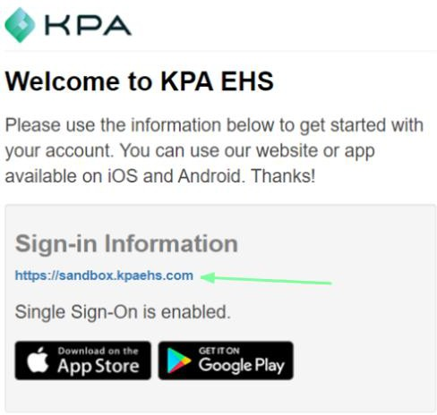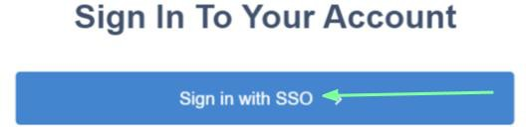

|  |
| --- |
| 3) Dashboard |
| *This is your homepage. If you have assigned open tasks to complete, you will see them listed here.*  *\*Note: This will be based on access level \** |

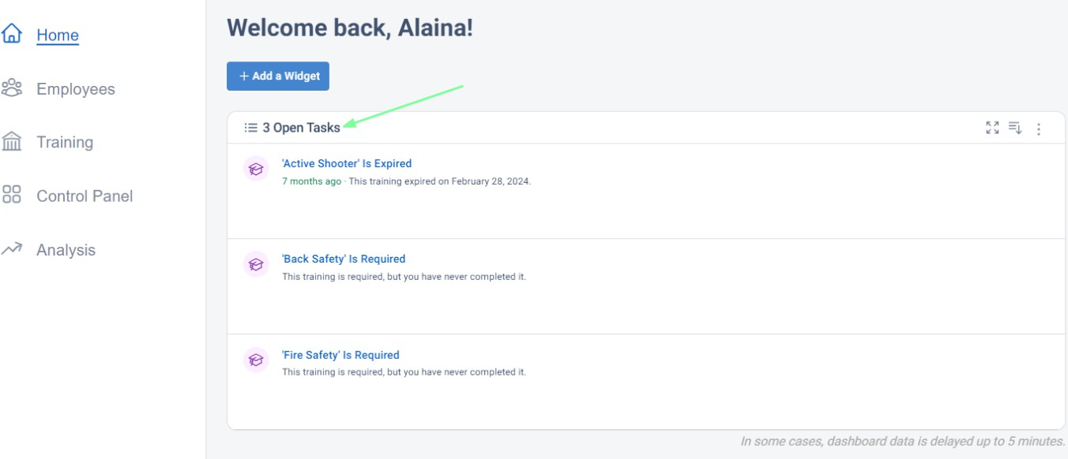

|  |
| --- |
| 4) Completing Training |
| *Click on the open task and click "Begin" to complete your training.* |

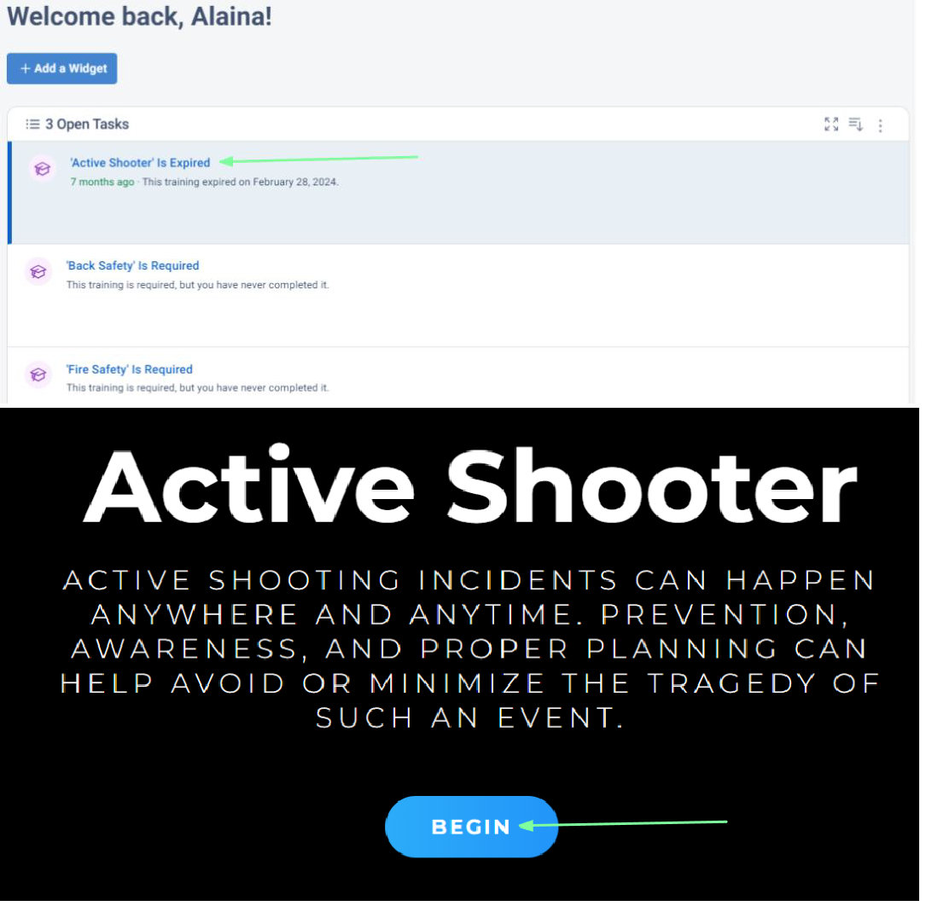

|  |
| --- |
| ***How To Use the KPA Flex App*** |
| *The KPA Flex App is available for iPhone, iPad, and Android devices.*  *The app allows you to ﬁll out reports without an internet connection, receive notiﬁcation, and more.* |

|  |
| --- |
| 1) Install the App from the App Store |
| *iPhone and iPad users can search “KPA Flex” in the Apple App Store. Android users can search “KPA Flex” in the Google Play Store. *Note: The KPA Flex app is free.\** |

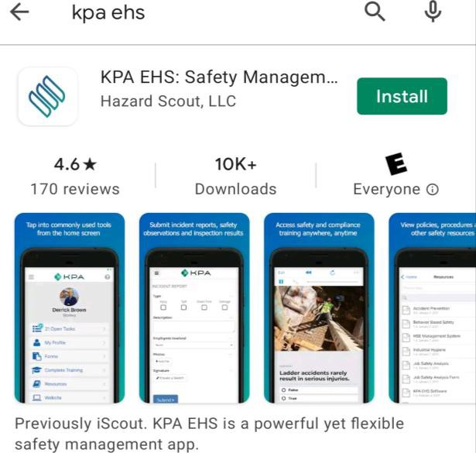

|  |
| --- |
| 2) Open the App |
| *Once you download the app from the App Store, you should see a KPA Flex icon on your device. Click on the app icon.* |

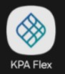

|  |
| --- |
| 3) Allow Access |
| *The app will ask to allow access to your photos and media. Make sure you press ALLOW when you are prompted.* |

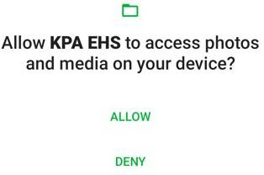

|  |
| --- |
| 4) Sign In |
| *Your company is setup with SSO, please always click on the Sign in with SSO button when signing into the KPA Flex app. The KPA Flex app will show both options to sign in with a username and to sign in with SSO.* |

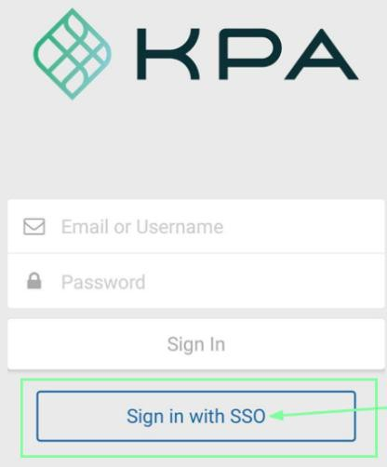

|  |
| --- |
| 5) Domain Name |
| *If the app asks for your Domain, this will be the portion between https:// and .kpaehs.com from your*  *website:* |

In this example, sandbox would be the Domain

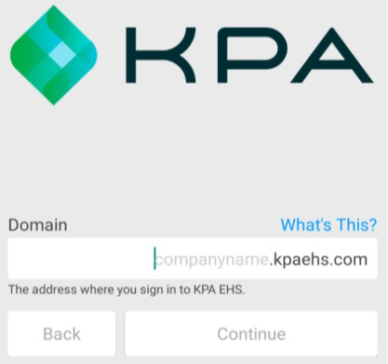

|  |
| --- |
| 6) Enable Notifications |
| *Now you need to conﬁrm that the system can send alerts to this device. Press “Yes” then continue.* |

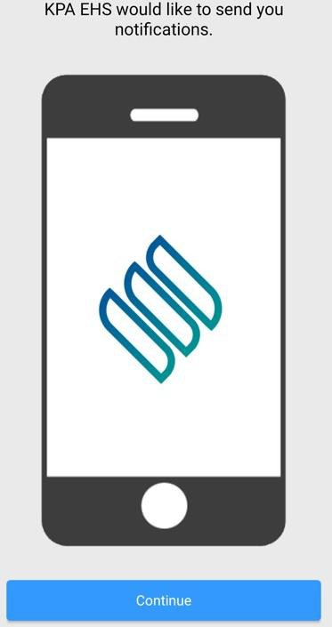

|  |
| --- |
| 7) Home Screen |
| *Congratulations, you’re in! You should see your name along with a few diﬀerent links for your open tasks, trainings, etc.* |

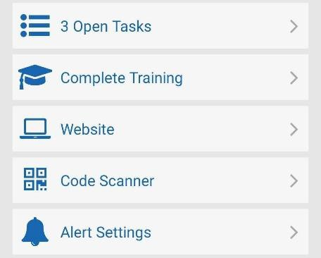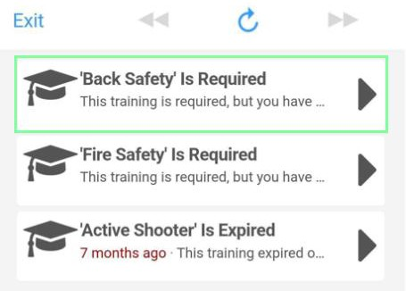

|  |
| --- |
| 8) Open Tasks |
| *The open tasks will show your current tasks to complete. These are your assigned trainings to complete. Click into each task to complete each one.* |

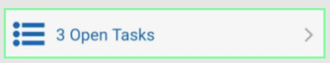

|  |
| --- |
| 9) My Profile |
| *My profile will show your unique QR code, profile data, and your completed training records.* |

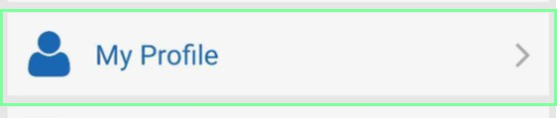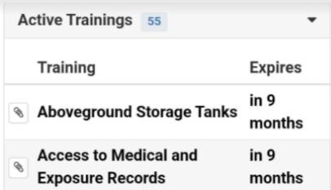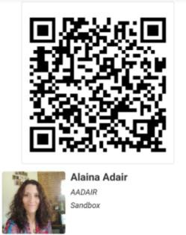

|  |
| --- |
| 11) Complete Training |
| *Complete Training are trainings NOT required trainings but available to take. To complete your required trainings, go through your Open Tasks.* |

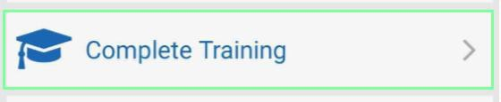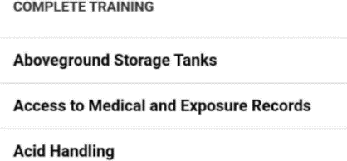

|  |
| --- |
| 15) Website |
| *The website button will allow you to get the full functionality of the website within an app view. Click*  *on the menu button to see the menu options.* |

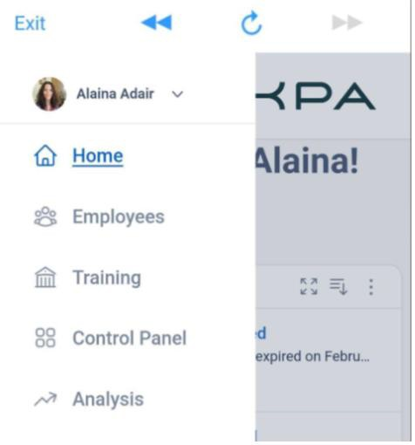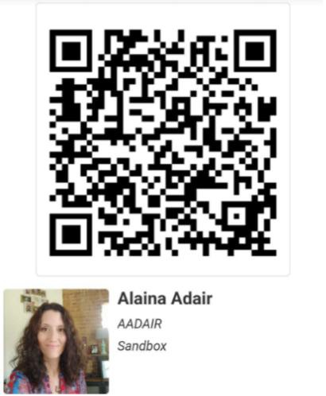

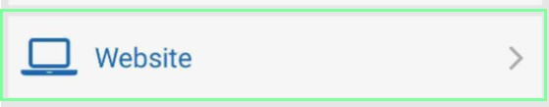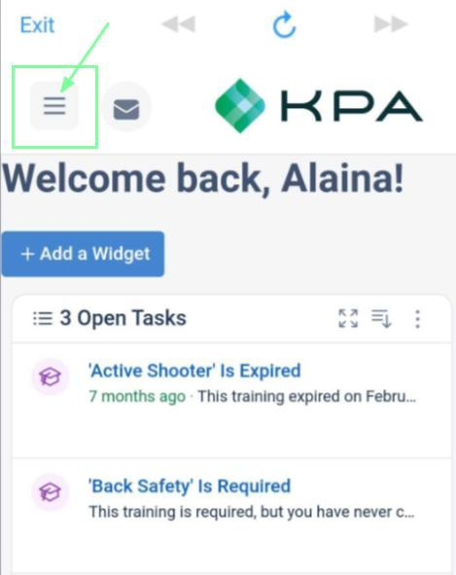

|  |
| --- |
| 16) Code Scanner |
| *Each employee and equipment added to KPA will have a unique QR code generated for that profile. The Code Scanner allows you to scan employee profiles.* |

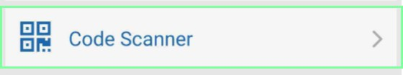

|  |
| --- |
| 17) Alerts |
| *Press the “Alert Settings” button to make sure alerts are enabled for your device. Your employee proﬁle on the website will let you send yourself a test alert to make sure it is setup properly.* |

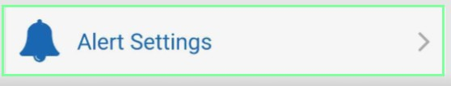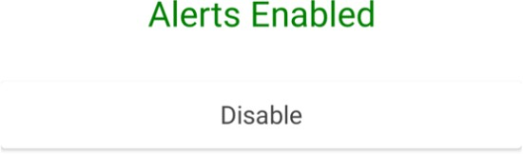

|  |
| --- |
| 18) iOS Alert Style |
| *By default, iPhone will show alerts at the top of the screen. If you wish to show them in the center of the screen, go to Settings App > Notiﬁcations > KPA Flex > Alert Style, & choose “Alerts”.* |

